**ALICE: Automatic Localization of Intra-Cranial Electrodes**

Written by Mariana P. Branco and Anna Gaglianese

**Please report any errors to** [**m.pedrosobranco@umcutrecht.nl**](mailto:m.pedrosobranco@umcutrecht.nl)

*"An article about computational results is advertising, not scholarship.*

*The actual scholarship is the full software environment,*

*code and data, that produced the result.”*

*Buckheit and Donoho (1995)*

1. **How to install ALICE?**

**1.1** The ALICE was primarily developed in a Linux platform. If you are also using a Linux platform be sure to had the following path to your .*bashrc*.

You can open your *.bashrc* by typing kate ~/.bashrc in the terminal. Kate is an example of an editor program.

Add the following lines (in blue) after the last **export/source** lines inside the **if [“$P1”]** branch:

**if [ "$PS1" ]; then**

**…**

#New AFNI path december 2016

#where AFNI is installed, e.g.:

AFNI_INSTALLDIR=/Scratch/AFNI/afni_2016-12-02/linux_fedora_21_64

# add the AFNI binary path to the search path

PATH=${AFNI_INSTALLDIR}:${PATH}

# Location of the plugins

AFNI_PLUGINPATH=${AFNI_INSTALLDIR}

# Location of the timseries models (also plugins)

AFNI_MODELPATH=${AFNI_INSTALLDIR}

# Location of the talairach daemon database

AFNI_TTATLAS_DATASET=/usr/share/afni/atlases

# Suppress warning for missing mpeg output

AFNI_IMSAVE_WARNINGS=NO

export PATH AFNI_PLUGINPATH AFNI_MODELPATH AFNI_IMSAVE_WARNINGS AFNI_TTATLAS_DATASET

# set PATH so it includes user's private bin if it exists

if [ -d ~/bin ] ; then

PATH=~/bin:"${PATH}"

fi

**fi**

**Save** the *.bashrc* file. **Close** the editor program and the terminal window. In a **new** terminal do suma –update_env .

**Note:** AFNI uses python **2**. So, make sure the command ‘python’ in the terminal uses python2.

* 1. Open MATLAB (version > 2015a).
  2. [**UMC**] Update your Juniper m-files/CTMR folder. The content of this source-code folder was recently changed. So, if you are updating for the **first time** the ALICE program, please delete the CTMR folder before updating your SVN. A new CTMR folder will appear with the newest code.
  3. [**General**] Download and unzip your ALICE source-code folder to a local directory on your computer.
  4. Add the source-code folder to your path using addpath or using the *Set Path* icon. And verify that SPM12 is in your MATLAB path too.

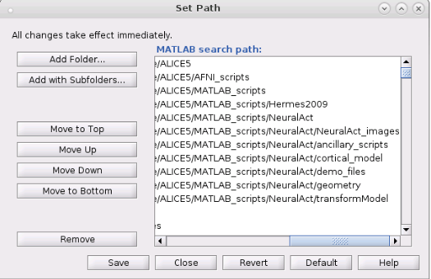

**2. Prepare input files**

Before starting running the program be sure to have the necessary input files. For that you have to run the FreeSurfer segmentation on the patient’s MRI anatomical scan. The ALICE procedure requires 3 input files: the **CT** (in *nii format), the Freesurfer **T1** scan (T1.mgz or T1.nii) and the Freesurfer **cortical ribbon mask** (ribbon.mgz or ribbon.mgz).

[**UMC**] Below you find instruction to convert MRI and CT scans to *nii and to run FreeSurfer segmentation on the MRI scan on the RIBS servers.

For most recent patients, T1 MRI structural scan can be foundin the patient folder /mrdata/ folder. Usually you can find this file inside the folder ./images/ANAT_.... Typically, this scan was acquired in the 3T scanner, in *.nii format and with voxel dimensions of **1 x 1 x 1 mm**.

CT scans are usually found in the ./CTscan/rawCT/ folder (in *nii format) inside the patient folder. In some cases, however, the T1 and CT scans are in *.ics/*.ids or *.dicom (*.dcm) formats. You can convert these to *nii using step 2.1 and 2.2.

Last, but not least, run Freesurfer segmentation described in step 2.3.

**2.1 Convert MRI data to *nii format**.

To convert *.ics/*.ids files to *nii, you need to (1) convert *.ids/*.ics to *.img/*.hdr format, (2) convert these to *.nii and (3) change the voxel size of the scan if necessary.

**(1) Convert *.ids/*.ics files in *.img/*.hdr files:**

1- Transfer *.ids/*.ics files from Fridge to local computer (via winSCP);

2- Open the *.ics in WordPad;

3- Open ImageJ program (freeware) and import (File > Import > Raw) the *.ids file;

4- Correct the parameters (*.ics parameters in bold):

a. Image type = layout size bits + Representation sign;

b. Width = layout sizes x;

c. Height = layout sizes y;

d. Number of images = layout size z;

e. Select Little-endian byte order.

5- File > Save as > Analyze > Save

6- Transfer the new *.img/*.hdr back to Fridge (via winSCP).

**(2) Convert*. img/*.hdr to *.nii:**

Run the command mri_convert ANATname.img ANATname.nii on the terminal. Save the new *.nii anatomy in the mrdata folder (see Note to install mri_convert function).

**(3) Change voxel size of the *.nii:**

1- Start SPM12 in Matlab.

2- Open the *.ics with wordpad (or equivalent)

3- In SPM click Display and select the *.nii (click Done).

4- Check the voxel size on the interface (right side, ‘Vox size:’), and compare to the ones in the *.ics file.

5- Enter the new values on the resize {x}, resize {y} or resize {z} on the left panel. Only enter the new values on the dimensions that are wrong.

6- Resize voxels by selecting the ‘Reorient…’ button.

**2.2 Convert *.dicom (*dcm) to *.nii format**

Call dcm2niix –f name_here –b n –z n . on the terminal located at the folder with the dicom images. Then, rename the *nii file to something more interpretable (e.g., CT_highres.nii) using the following terminal command:

3dcopy Date_code.nii CT_highres.nii

**2.3 Run FreeSurfer segmentation**

Run the Freesurfer segmentation on the T1 .*nii file. For that, run the following command on the terminal:

export SUBJECTS_DIR=/Fridge/bci/data/PROTOCOL/PATIENT_NAME/mrdata/

recon-all -subject Freesurfer -i PATH_TO_ANATOMY -cw256 -all

|  |
| --- |
| **Note:** |
| To run mri_convert and Freesurfer recon-all segmentation, first add FreeSurfer to your *bashrc*. In the terminal do:    >> kate ~/.bashrc  Add the lines:  export FREESURFER_HOME=/usr/local/freesurfer  source $FREESURFER_HOME/SetUpFreeSurfer.sh |

This procedure takes about 12 hours, so be patient. Once completed, a folder named Freesurfer will be available inside the patient’s ./mrdata folder. In ./mrdata/Freesurfer/mri you will find the two files necessary to run ALICE: T1.mgz and ribbon.mgz. You can also input these files into ALICE using a *.nii format (e.g., mri_convert ribbon.mgz ribbon.nii).

**!! Note**: Freesurfer segmentation always resamples the anatomy to **1 x 1 x 1 mm**. In the cases where the anatomy has sub-millimeter dimensions (e.g., 0.6 x 0.6 x 0.6 mm) the Freesurfer segmentation will run, but the resulting files may be distorted and lead to problems during the coregistration step (see **section 4 step 1** for more details).

At this point you should have the three input files available in the patient folder:

* MRI: mrdata/FreeSurfer/mri/T1.mgz **or** converted *.nii file
* FreeSurfer: mrdata/FreeSurfer/mri/ribbon.mgz **or** converted *.nii file
* CT: CTscan/rawCT/*.nii

**3. Overview of the user interface**

Locate MATLAB current directory to the folder where you wish the program to save the output files (use /Fridge/bci/data/protocol/subject_name/analysed/). Be sure to have writing permissions in that folder.

Start the ALICE program by typing ‘alice’ in the MATLAB command window:

>> alice

The following window with open:

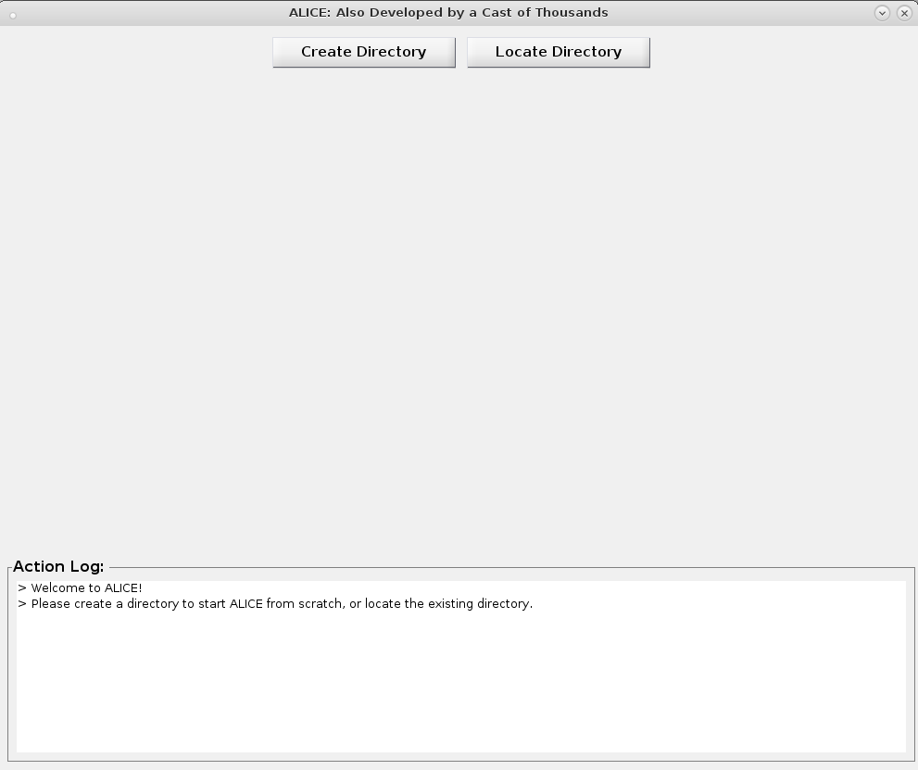

Now you are ready to start the electrode localization procedure. All actions and instructions are provided in the **ACTION LOG**. For more details follow the steps described in the next sections.

**4. Start the electrode localization procedure:**

The first step in the pipeline is to create a folder were all the input and output files will be stored, labeled and logged.

When you start the program two buttons appear on the top (see figure above). Choose to:

1. **Create a folder:** If you are starting the program for the first time for a given subject, choose **‘Create Directory’**. The program will create a new directory where the important files are stored. When necessary the program will also copy functions to the respective folders.
2. **Or Locate an existing one:** If you have previously created a folder *using this pipeline*, interrupted the pipeline and now wish to proceed with the program, choose **‘Locate Directory’**. When loading a directory, the program will automatically recognize the source files and display the path on the interface. No need to load the files again.

The ALICE folder is organized as follows:

|  |
| --- |
| * MRI * Freesurfer * CT * coregistration * 3Dclustering * data   intermediate_results  hemisphere  method   * results * log_info * pictures |

The original files, renamed, will be copied to the corresponding folders. Please do not copy or move the files yourself, strictly use the interface to locate and copy the (source) files.

All steps that you perform will be logged inside ./log_info in three separate files for the three procedural steps. These files are useful to keep track of the steps performed in case debugging is necessary.

Coordinates and cortex (*.mat and *.txt) files are saved in ./results/method/hemisphere/ and intermediate files are saved in ./results/method/hemisphere/intermediate_results/. PNG pictures of the projected electrodes displayed on the brain surface are saved in ./pictures.

Now, follow the three steps indicated in the interface:

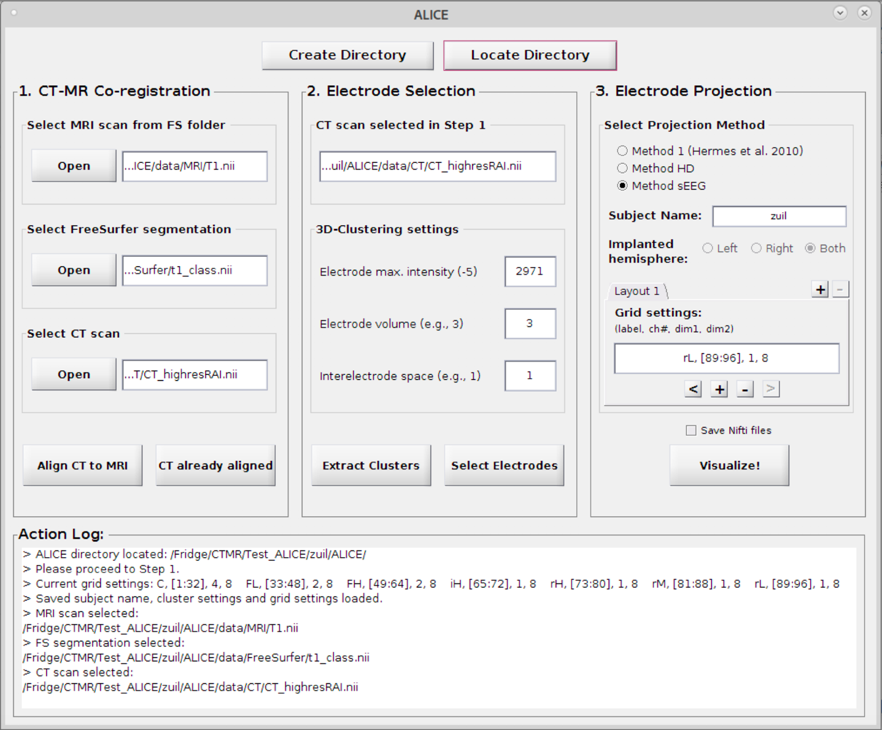

**1)** **STEP 1:** **Locate the input files (if not yet loaded with LOCATE DIRECTORY).**

Use the ‘Open’ buttons to locate the source files (FreeSurfer T1, FreeSurfer ribbon and CT). These will be copied, renamed and moved to the ALICE folder.

Align the CT to the MRI by selecting **‘Align CT to MRI’**. This function will take some time. Be patient.

Once the alignment finishes, AFNI will open and a help message will be displayed with some instructions. AFNI will automatically set the T1 as underlay and the CT as overlay.

To change the transparency of the CT layer use the up-down buttons on the slices view (see figure below, white arrow). Scroll through the slices using the scrolling bar on the button of each view-window.

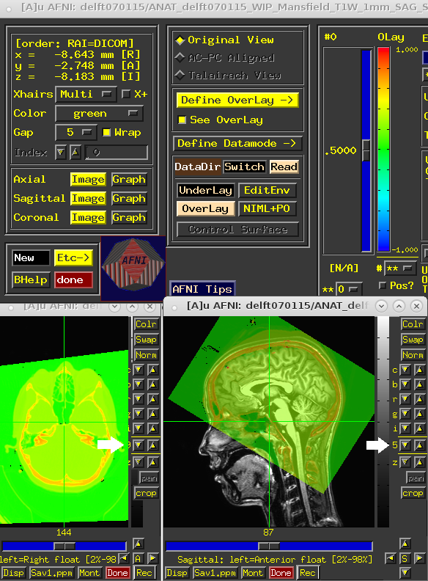

If the alignment is good, please close AFNI and proceed to **step 2**. If the alignment does not work, there are couple possibilities why:

1. Sometimes the *.nii from *.dicom conversion does not work properly. If that is the case, the alignment fails, and you should use the *.nii from *.img/*.hdr instead. If that is not available then another alignment method must be used. Contact us for help.
2. Sometimes the original T1 anatomy scan has submillimeter dimensions (e.g., 0.6 x 0.6 x 0.6 mm). In those cases Fressurfer segmentation runs but the output T1.mgz file is not proper. In this case use the original anatomy in the alignment step instead. However, in order to ensure correct electrode projection, be sure that the original T1 scan and the Freesurfer T1.mgz/nii are in the same space (i.e., aligned). You can check this in MRIcron or SPM. If these are not aligned, do not proceed and contact us for help.

**2)** **STEP 2:** **Extract the electrode clusters and centers-of-mass.**

The original CT (loaded in step 1) will be displayed on the top of Step 2.

In this step three parameters can be specified for the extraction of the clusters from the CT:

* Electrode maximum intensity. This value is used to threshold the CT scan in order to cluster volumes above the value. This value will be automatically predicted from the CT file. Please feel free to change this value if the estimated one is too high.
* Electrode volume. This value is a measure of cluster volume. Typically, 3 works for clinical and high-density electrodes.
* Interelectrode space. This value is a measure of distance between the clusters. The value 1 is used as standard, however in some difficult cases (many overlapping electrodes or small high-density grids) 0 might work better.

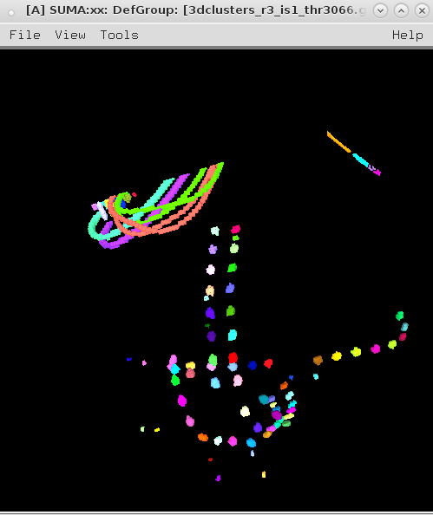

Select the **‘Extract Clusters’** button. This function may time some time. Be patient.

Once extracted, SUMA will open. Please check the result in the SUMA interface by using the left-mouse click to rotate, mouse-scroll to zoom in and out, and scroll-lock to pan.

If you see all electrodes well defined by clusters, close SUMA and proceed to the next step. Otherwise, repeat procedure with other parameters.

**3)** **STEP 2: Select the electrodes.**

It is time to select the electrodes using the leads layout (electrode layout). Knowing the electrode order and the grid relative position, as described intraoperatively, locate each electrode in SUMA and select the electrodes one-by-one. Below you see an example of one subject implanted with of three grids (C, IHH and IHL), which are recorded in the channels 1 to 16, 17 to 24 and 33 to 64, respectively.

|  |  |  |  |
| --- | --- | --- | --- |
| Screen Clipping | |  | |
| **Electrode grid relative position and label.** | | **Leads order per electrode indicated in the**  **‘channels’ column.** | |
| **!! Having this information at hand is very important for this step** | |

Select the button ‘**Select Electrodes’**. At this point, three programs will be displayed: AFNI, SUMA and a small Matlab interface (see right panel below). If you do not see one of the interfaces please check AFNI and SUMA are in the *bash* and if you are using the latest version of all the software, or contact us. A message dialog will also be prompt to help guide you through the selection process. Read the instructions in the **message dialog** for more information about the interfaces. When read, please press ‘**OK’**.

**!! Note:** We recommend to organize the windows as follow: AFNI main interface and SUMA object controller can be minimized, SUMA maximized and Matlab electrode selection interface on the side (see below an example).

|  |  |
| --- | --- |
|  |  |

Use SUMA to select the clusters, using the right mouse click. AFNI jumps to the correct volume position. Navigate in AFNI using the left mouse click.

Use the **‘Select Electrodes’** window or specific keys to select the electrodes. Here you can see the current electrode number to be selected.

**For each electrode you have the options:**

1. ‘**Select electrode’:** Select a cluster in SUMA (right-mouse click) and then push the button ‘Select electrode’. ‘Select electrode: X’ string on the top of the interface will update accordingly. **The selected electrode will become white**. Please note that usually clinical grids have a marker (smaller) electrode between the first two electrodes of the grid. This makes it easier to identify where to start counting.
2. **‘Set sphere’:** Sometimes a cluster may be missing or may embody two electrodes. Then use the AFNI volume interface to locate the electrode center-of-mass (left-mouse click to select a voxel) and use the button ‘Set Sphere’to create a new cluster around that point.
3. **‘Go to electrode’:** Sometimes there are channels without ECoG electrodes (see patient example above between channel 25 and 32). In that case, you can choose to go to a specific number (33) using the ‘Go to electrode’fieldand select enter **‘>>’.** You can also choose to redo specific electrodes by using the same field.
4. **‘Delete cluster’:** This option paints the electrode black.
5. **‘Finished!’:** When done, select ‘Finished!’. Be patient and **wait until the program closes all windows**.

**4) STEP 3: Project the electrodes.**

Project electrodes using the **Method 1** for clinical grids and **Method HD** for high-density grids or **Method sEEG** for stereo-EEG.

|  |  |
| --- | --- |
|  | **Method 1 (Hermes et al. 2010):**  Enter the subject **name** and choose the **hemisphere** where the grids were implanted. Add grid information necessary to the orthogonal projection method (Hermes et al. 2010).  Per grid insert the grid label (‘**C**’), the electrodes (cluster number) to which it corresponds (**[33:64]**) and the grid size (**4 x 8**). Select **‘Add Grid’** to add the grid information.  Use the **Action Log** to check which grids were added or deleted.  If you make a mistake you can remove the information add by clicking **‘Delete previous grid’.**  Press ‘**Visualize!’** to project the electrodes and see the result. You will see the projection figures and the final result popping-up.  **Method HD (no projection, just display):**  This method allows displaying the electrode on the surface assuming the distance from the electrode to the cortical surface to be small (Kubanek and Schalk 2015). Press ‘**Visualize!’** to project the electrodes and see the result. Two figures show the result before and after being displayed on the surface. |
|  | **Method sEEG:**  This method will use both hemispheres automatically. No projection performed. Run similarly to Method 1 and Method HD. The output are three brain views saves in png format. |

**Congratulations!**

**You have completed the ALICE procedure.**

The output files were saved in the folder /results/method/hemisphere.